Request for Quotes –
CEILING HEATER – HVAC CLASS

10/8/2019

Agency: Charleston Job Corps Center
1000 Curtis Price Way
Charleston, WV 25311

This is a Subcontracting Opportunity

- SOLICITATION
This Request for Bid is provided for Ceiling Heater in HVAC Classroom located on the center as set forth below in the SOW for the Charleston Job Corps Center operated by HYS Corporation under Contract number DOL-ETA-1630J2-18-C-0006 with the United States Department of Labor. The extent of the work is described below.

The general conditions of the contract for this project shall be consistent with the Federal Acquisition Regulation (FAR) except as modified or amended herein. A copy of the FAR can be obtained on-line at http://farsite.hill.af.mil/vmfara.htm.

If it becomes necessary to make changes in quantity, specifications, delivery schedules, etc., or to correct a defective or ambiguous invitation, such changes shall be accomplished by amendment of the solicitation. Amendments shall be sent to everyone to whom invitations have been furnished.

To be considered for award, a Quote must comply in all material respects with the Request for Quotes. Such compliance enables bidders to stand on an equal footing. Bidders who do not provide the requested responses will be consider non-responsive.

Quotes should be filled out, executed, and submitted in accordance with the instructions in the invitation. If a bidder uses its own bid form(s) or a letter to submit a Quote, the Quote will be considered only if --

(1) The bidder accepts all the terms and conditions of the invitation to quote; and

(2) Award on the Quote would result in a binding contract with terms and conditions that do not vary from the terms and conditions of the invitation.

Quotes submitted by electronic commerce shall be considered, provided they are timely. Electronic Quotes must reference the solicitation and be sent to Blake.Petra@jobcorps.org

- REPRESENTATION
- Codes
  - The contractor shall research, and be responsible for obtaining, all regulatory, permitting, and licensing requirements.

  - All conflicts and requests for interpretation or clarification shall be submitted to the Charleston Job Corps Center Director.

  - The contractor shall conform to all applicable construction codes, ordinances, and regulations including the national building code used in the local area, laws and local ordinances. All work shall conform to the current regulations of the Environmental Protection Agency (EPA), and the Occupational Safety and Health Administration (OSHA). The regulations of the District of Columbia shall prevail, if they are more stringent than those of the Federal Government. Deviations and interpretations shall be subject to the approval of the Charleston Job Corps Center Director and the Department of Labor.

  - The contractor shall not submit plans or specifications to any local authority without the prior approval of the Charleston Job Corps Center Director or designated representative.

- Specific Requirements
The prospective offerors must take such steps as may be necessary to ascertain the nature and condition of the work, and the general and local conditions which can affect the work or cost thereof. Failure to do so shall not relieve offerors from the responsibility for estimating properly the difficulty or cost of successfully performing the work.

- A pre-bid site visit will be held on Tuesday, October 15, 2019 at 11:00 PM for interested bidders.

- Bidders, if applicable, will be responsible for submitting any questions to the Buyer in writing by Tuesday, October 22, 2019 by COB. Buyer will respond to all questions by all potential bidders.
  - All bidders are responsible for reviewing these specifications along with all attachments thoroughly and submitting any questions regarding these specifications or work activities described below to the Buyer during the question/answer period discussed above. The Contractor that is awarded the contract will be expected to abide by under the scope of work described in these specifications completely.

- Quotes must be submitted by Tuesday, October 29, 2019 by COB
- Once awarded, Contractor must be able to start work in 5 business days. Work must be completed by December 31. 2019.

- Any proposed interruption to center operations must have prior approval from the Center Director after a minimum of 72 hour notice. The center and its buildings shall remain in operation throughout the project. All project activity and contractor access to the building interiors shall be coordinated with the center in order to minimize disruption of center operations. No work will be performed on weekends unless the contractor receives prior approval in writing from the Center Director.

- It is the contractor's responsibility to provide any and all elements which are incidental to the functioning of the work to be provided. It is not intended that other deficiencies that are not related to the work identified in this Scope be corrected. The contractor shall limit its efforts only to the work that has been identified (including affected areas) in this Scope of Work.

- For work scheduling, the contractor shall provide a proposed sequenced schedule to the center as part of the proposal submission

- All materials and hardware shall be selected for their ease of maintenance, high durability, and local availability; and shall be coordinated with those currently used by the center. Restoration of damaged elements shall be promptly executed in like materials, as a part of this contract.

- The contractor shall be responsible for all cutting and patching incidental to the work described herein. The contractor shall promptly repair/replace any damage to structures, elements, utilities, finishes, etc., occurring due to work incorporated in this SOW, as a part of this contract.

- The contractor shall ensure the security of operations and storage areas to preclude all breaches of security including, but not limited to vandalism and/or theft that can impact the timely and successful completion of the work. While existing center operations will be continuing during the course of the project, the contractor shall not rely on any aspect of center security to guard aspects of his operations. At no time during this project duration, up to and including the acceptance of the substantial completion walk-through, will the Charleston Center accept requests for additional security measures. HYS Corporation/Department of Labor shall not be held to have incurred any liability for loss of, and/or damage to, materials, tools, and equipment of the contractor by contract or otherwise. HYS/Department of Labor shall not in any way be liable or responsible for damage or loss to work due to trespass or theft.

- Contractor will be financially liable for all damages and/or service interruptions resulting from work being performed by Contractors employees. Charleston Job Corps Maintenance Manager must be notified immediately of damages or service interruptions. Any subcontractor used to make repairs or provide service on the Contractor’s behalf must be approved in advance by Charleston Job Corps Center Director, or designated representative.

- The contractor shall maintain a clean and safe work area throughout the period of performance. The contractor shall, at the end of each work day, remove and secure all debris, tools, equipment and materials used. The contractor shall collect used or excess chemicals frequently and dispose of chemicals and refuse away from the center in a lawful manner. The contractor shall be responsible for all fees, permits, etc., required for waste disposal for the duration of this contract. If Contractor fails to comply with the daily removal of debris, trash, chemicals, etc. as required, Charleston may remove and charge the Contractor the entire cost. Contractor shall not utilize Charleston trash receptacles for debris, trash or chemicals. The contractor will prevent the spread of dust to neighboring sites and properties and avoid the creation of a nuisance or hazard in the surrounding area.

- The contractor shall be responsible for receiving, storing, and securing of all materials, chemicals, equipment and other items to be used in accomplishing the work. Contractor’s supplies and equipment may not be stored on the center unless expressly permitted by Charleston Job Corps Maintenance Manager. The contractor shall be responsible for all equipment, chemicals and materials brought onto the center to support this SOW, and shall replace lost, damaged or stolen items at its own expense.

- The contractor and all persons employed under the contract:

- Shall observe all security regulations in effect at the center;
- Shall not fraternize with the students or staff of the center;
- Shall not consume or transport any alcoholic beverages or drugs on the center;
- Shall not transport any firearms on the center;
- Shall not use the center’s dumpsters

- Persons violating the above shall be dealt with in an appropriate manner.

- Offerors licensed in WV are welcomed and preferred. Licensure must be valid and current as of the time of proposal submission and for the expected duration of the task. Bidders must provide documentation validating these licensure requirements with their proposal packages.

- The contractor is responsible for complying with the jurisdiction having authority, drawings and specifications prescribed inspection & testing and any manufacturer prescribed inspection & testing.

- The contractor will coordinate with the Center for location of equipment and material staging areas, and for vehicle parking. Following completion, the contractor shall return the site conditions to their original state.

- Electricity will be made available by the Center to the extent practical based on proximity to buildings and suitable electrical power connections. Connections to Center electrical power shall be by the contractor. If the Contractor requires electrical power outside of a reasonable distance from an existing building power connection, they must provide it via generator or other Contractor-supplied means.

- CJCC has the right to Stop Work if the Contractor fails to correct defective work as required or continually fails to adhere or perform the work in accordance with these specifications, the scope of work or contract documents. The Center Director or their representative, may order the Contractor to stop the work, or any portion thereof, until the corrections are made and acceptable by CJCC.

- Contractor’s employees must be dressed in uniform clearly identifying them as the Contractor’s employee and according to safety regulations at all times during the performance of this contract. Uniform exceptions may be presented to the Center Buyer for consideration and approval.

- Contract Type – Fixed Price quote for Insulation. Prevailing wages under the Service Contract Act apply.

- Special Conditions
  - Acceptance of “As Is” conditions
Prior to performing any work at or on an existing center, the contractor shall tour that element with the designated representative of the center for the purpose of defining the limits of the work area and establishing existing conditions. Once the center and contractor agree on the “As Is” condition the contractor may take possession of that element for the purpose of performing the work. The Offeror shall protect all existing items within the work limits which are not specifically part of the work in the Contract and, at the completion of his work shall restore as necessary the work area to the “As Is” condition agreed to with the center prior to commencement of the work. If there is concern that the work area contains damaged elements that might appear as damage caused by the prosecution of the work, the contractor shall document the damage through memo or video tape the work area and provide a copy to the center prior to commencing any work. The center may make its own video of conditions, if desired.

  - Contractors’ possession of the work
Once the contractor accepts the work area(s) and the “As Is” conditions (item 1 above), the contractor is responsible for protecting and insuring everything within the work area against damage and harm. Only when the center executes a substantial completion certificate for the work completed in a specific work area will the contractor be relieved of responsibility for the protection of that work area.

Schedules and Delays
The contractor shall, upon acceptance of award, perform the work in accordance with the Scope of Work, and start work on a date and time as set forth in the SOW within 5 (five) business days. A finalized schedule will be submitted and accepted prior to the issue of the Notice to Proceed (NTP) by the center. All work, including punch list items, shall be completed as set forth in the SOW.

The contractor shall immediately notify the center of any expected delays in the acquisition of materials which may delay the completion of the project. Should this impact the approved schedule, the contractor shall adjust the schedule and resubmit it for center approval. No extensions in time will be granted unless the modified schedule is approved in advance by the center.

- INSTRUCTIONS – BID SUBMISSION REQUIREMENTS
All offerors must address the items listed below in their submission in order to be determined technically acceptable. Failure to address these requirements will result in the offeror being deemed unresponsive.

- Offers must provide evidence of licenses and certifications to perform the scope of work.

- Offerors must not be excluded from competing on government contracts. Verification will be completed through the SAM portal.

- Offerors shall submit a fixed price quote based upon the SOW and Extent of Work outlined in the Schedule. Labor and materials cost must be detailed in the response.

- A proposed schedule to complete all work in accordance with the statement of work must be provided.

- The contractor must include with his/her quote, conformance to the latest Service Contract Wage Rate decisions for Charleston, WV through the submission of the SF-1413.

- A minimum 60-day bid guarantee is required

- The contractor must include a listing of the valid and current credentials for all staff assigned to perform the work. The credentials should demonstrate the vendor’s ability to successfully perform the SOW.

- The contractor shall provide a list of similar projects completed by its firm within the last five years and a list of references, including owners' names, addresses, email and telephone numbers. All firms submitting quotes for this project shall have no less than five consecutive years of relevant experience.

- This project is sales/use tax-exempt.

- Offerors must provide a warranty covering all materials, workmanship, and labor. Warranty period must be consistent with industry standards and norms.

- Contractor shall provide a certificate of insurance naming HYS Corporation – Charleston Job Corps Center as an additional insured, per Section IV - insurance requirements.

- Contractor must accept purchase orders with net terms.

- Contractor must provide a completed New Vendor Profile (Sample in Attachments) & W-9

- SCOPE OF WORK (SOW):

This Statement of Work describes general and specific services for the maintenance, repair, and construction for Charleston Job Corps Center in Charleston, WV. The Charleston Job Corps Center has a requirement to provide routine service, maintenance, repairs, and construction services for approximately 14 buildings located on the grounds. This service includes; HVAC systems, electrical, power systems, telecommunication, building/shelter maintenance, landscaping, road maintenance, pest control, and general facility upkeep.

- Remove current ceiling hung heater
- Install new ceiling hung heater (1)

- Purchasing, delivering, and installing of all supplies required for completion of work
- Daily and/or weekly updates of progress of work to be reported to Maintenance Manager
- Services shall begin (5) five business days from award
- Work must be completed by December 31, 2019

- INSURANCE
Prior to starting any work, the contractor shall show proof of required insurance, in amounts to cover risk or as required by statute, including:
- Bodily Injury Liability - $500,000 each person; $1,000,000 each occurrence and will include coverage for owned, non-owned, and hired vehicles.
- Property Damage Liability - $500,000 each accident; $500,000 aggregate
- Workers Compensation and Employer’s Liability – Amounts in coverage as required by the District of Columbia compensation laws or union agreements. Employer’s liability at least $500,000 each accident. Amount shall remain in effect for a minimum of one year from the time of substantial completion, but in no event less than the time required to complete all warranty work.
- Umbrella Liability – $5,000,000.00 each occurrence

Once awarded, Contractor must maintain and keep current the above limits for the entire period of performance. It is the contractor’s responsibility to provide a new and/or replacement Certificate of Insurance at least (15) fifteen days prior to the expiration of such policy. Contractor must give CJCC at least (30) thirty days’ prior written notice of cancellation or termination of coverage.

- EVALUATION FACTORS FOR AWARD:
- HYS anticipates the award of a single contract as a result of this solicitation to the responsible Offeror whose proposal meets the needs of the solicitation, adequacy and availability of candidates, credentials and related experience, and is determined to be the lowest price.

- Invitations may be cancelled and all quotes rejected before award when:
- All otherwise acceptable bids received are at unreasonable prices, or only one bid is received and the contracting officer cannot determine the reasonableness of the bid price;
- The bids were not independently arrived at in open competition, were collusive, or were submitted in bad faith (see Subpart 3.3 for reports to be made to the Department of Justice);
- No responsive bid has been received from a responsible bidder;
- For other reasons, cancellation is clearly in the company’s best interest.

- ACCEPTANCE OF WORK:

SUBSTANTIAL COMPLETION
Substantial completion of the work is defined herein as the point at which the work is complete in all respects except for a few minor items which are to be listed on the contractor’s punch list. With the issuance of a substantial completion certificate executed by the center and the contractor, the center will occupy/take possession of the work. Prior to the issuance of an executed substantial completion certificate the contractor shall have had all tests completed, witnessed and approved by the center’s authorized representative. The provision of all required training, operating and maintenance manuals and other such requirements specified in this Scope of Work shall be a prerequisite to the contractor’s notification requesting a substantial completion walk-through.

The contractor shall notify the center in writing at least seven calendar days prior to the estimated date of substantial completion and request a substantial completion walk-through. The letter shall include a dated punch list as developed by the contractor. The purpose of the walk-through is to review the contractor’s list for accuracy and to identify any additional items needing completion prior to final acceptance. The contractor, shall, upon receipt of a substantial completion punch list, correct his work as required within 7 calendar days or until acceptable to the center. The substantial completion walk-through shall be performed by the Center Director and/or the designated representative.

FINAL INSPECTION
The contractor shall inform the center in writing at least three days prior to the estimated date of the completion of the work and request a final acceptance inspection.

The contractor shall guarantee all workmanship done under this Scope of Work for a period consistent with industry standards and norms for storefront doors installed in residential and food service facilities prior to final payment, the contractor shall deliver to the center and release of liens by all subcontractors and material suppliers associated with this project.

- EXTENT OF WORK

Inspection
- The Contractor is responsible for all inspections.
- All inspections shall be documented by certified written reports.

Adherence to the Scope of Work
- Although this scope of work identifies specific elements it is the contractor's responsibility to provide any and all elements which are incidental to the functioning of the work to be provided. It is not intended for other deficiencies not related to the work identified in Section III to be corrected. The contractor shall limit its efforts only to the work identified in this scope of work.

- PROJECT REQUIREMENTS & SPECIFIC CONDITIONS OF THE AGREEMENT:
- Codes
In accordance with the Scope of work, the contractor shall obtain all applicable permits and comply with all applicable building and safety codes, ordinances and regulations which are informed by City, County, State or relevant Federal agencies. OSHA and EPA regulations shall also apply.
All conflicts and requests for interpretation or clarification regarding permits and codes shall be submitted in writing to the Buyer, Charleston Job Corps Center.

- Service Contract Act
This project is subject to the provisions of the Service Contract Act for service work on a federally funded Job Corps center. Accordingly, the contractor shall be required to conform to the latest wage rate decision for the locality. The latest Service Contract Act wage determination can be found at: https://beta.sam.gov/.
The contractor shall provide written confirmation of compliance with wage rate and fringe on company letterhead and provide to the Buyer with certification that employees are being paid according to payroll records. The Certified Payroll Records shall be submitted to the Buyer using the sample form in Attachment 4.

The current form and instructions for using the form (wh347 dated 2008), and obtaining a fill able PDF of the form, can be obtained on the web at http://www.dol.gov/whd/forms/wh347instr.htm . The contractor shall submit a copy of all weekly payroll forms with each invoice for payment, accompanied by a signed "Statement of Compliance" indicating that the payrolls are correct and complete and that each service employee has been paid not less than the proper Service Contract prevailing wage rate for the work performed if required. The Buyer will compare the payroll record with the daily visitor sign in log. Any discrepancies between the payroll record and the center log shall be reconciled by the Contractor before a progress payment will be made. The Contractor shall be required to post bilingual (English, Spanish) signs in prominent locations at the project site informing all workers of their right to Service Contract wages.

- Invoicing/Certified Payroll
Invoices shall be rendered by Contractor with net terms. Weekly certified payroll must accompany every invoice in order to be accepted. Net terms begin upon review and acceptance of certified payroll. CJCC reserves the right to withhold payment due to contractor until the vendor provides compliant certified payroll and required documents.

- Indemnification
To the fullest extent permitted by law, Subcontractor shall defend, indemnify and hold harmless HYS Corporation, U.S. Department of Labor, Parsons and its stockholder, employees, technical advisors, agents, successors and assigns from and against all claims, damages, losses, and expenses, including but not limited to attorney fees, or actions in respect thereto, whether caused by that its negligence or intentional acts or omissions, arising out of or resulting from the performance of its (or its employees, contractors, or agents) work under this Agreement. This indemnification shall include claims for property damage, and for loss or expense attributable to personal injury, sickness, disease, or death or injury or destruction of tangible and non-tangible property including the loss of use resulting there from. Neither party shall be responsible for failure to perform under this Agreement due to circumstances beyond its control. This clause shall survive the term of this Agreement.

- Facility Operating Hours
The center shall remain in operation at all times throughout period of performance. All project activity shall be coordinated with the Maintenance Manager in order to minimize disruption to center operations. All anticipated interruptions to center operations shall have prior approval from the Maintenance Manager at least 36 hours in advance of the interruption.

- Supervision and Discipline
The Contractor shall provide a competent supervisor, or lead person who is qualified, certified, and capable of overseeing activities and authorized to act on behalf of the contractor and direct the work. The contractor's employees shall conduct themselves in an orderly manner and adhere to all the center rules and regulations. Contractor shall be responsible for all precautions as may be necessary to fully protect their work both during its execution and until its final acceptance or the Contractor shall be held responsible for all damages incurred. Contractor shall be responsible to CJCC for the acts and omissions of their employees, subcontractors and their agents and employees, and other persons performing any of the work under a contract with the Contractor or on behalf of the Contractor.
The Center and HYS reserve the right to direct the removal of any Contractor's employee for conduct in violation of center regulations or conduct which is deemed detrimental to the center operation.

- Supplies/Chemicals
The contractor shall provide all supplies, parts, materials, equipment and chemicals needed to perform the SOW. Contractor is responsible for monitoring and safety storing chemicals while conducting work on center. Contractor must provide a copy of all Materials Safety Data Sheets (MSDS) for all products used on center to Center Buyer. Contractor must also maintain a copy of all MSDS sheets while on center. These sheets must be made available upon request by Charleston Job Corps staff. Contractor shall ensure all supplies and chemicals are environmental friendly. Contractor will maintain a log of chemical applications made by employees. The log will note all application locations, amounts applied and dates of application. Entries into the log will be noted and made part of the weekly service report provided to the Maintenance Manager. Chemical use around pool, storm drains or any water is not allowed.

- Changes in the Work
Minor changes in the work that, the Center or Contractor may recommend and, do not involve adjustment to the Contract Sum or the Performance time shall be made through written instruction from the Purchasing Agent authorizing the Contractor to proceed with the agreed upon changes.
Changes in the work that do involve adjustment to the Contract Sum or the Performance time or both are Contract modifications that shall be executed as Change Orders on AIA Document G 701 or equivalent. Reference the Federal Acquisition Regulation (FAR) 52.243-4. For Contract modifications requested by the Center or initiated by the Contractor, the Contractor shall prepare and submit for approval, a change order proposal (see attachment 11). Procedures for preparing and processing change order proposals shall be as follows:

- The proposal shall include a statement outlining the reason for the change, i.e. unforeseen conditions, product substitution, and complete description of the change.

- Include a list of quantities of products to be purchased and unit costs. Indicate the amount of trade discounts.

- If product or system substitution is being requested, provide complete supporting data from both specified product/system and proposed substitute product/system for evaluation by the Center. Provide additional information to substantiate products and/or systems are equal or better with respect to this project application.

- Include a statement indicating the effect the proposed change will have on the Contract performance time (number of days added or deleted) and construction schedule.

- Show the total cost of the proposed change in such change order proposals that increase the contract.

- When the Center and the Contractor both agree to the change request as proposed or as modified, the Purchasing Agent will issue a Contract modification, Change Order for the Contractor's signature and the Center Director's signature, approving the change.

The Contractor is responsible to keep the work progressing on schedule. Requests from the Center for changes in the work and change order proposals are for information only and shall not be considered as instruction to stop work in progress, or to commence work on the requested change

IX. PERIOD OF PERFORMANCE
Services shall begin (5) five business days from award. A schedule for completion will be requested and negotiated.

X. Attachment 1 – Contract Clauses by Reference
This contract incorporates one or more clauses by reference, with the same force and affects as if they were given in full text. Upon request, the Buyer shall make their full text available. General terms and conditions are made part of this agreement – copies are available at:
http://workwithjc.weebly.com/
XI. Attachments 2-5
Attachment 2: Vicinity Map
Attachment 3: Site Plan
Attachment 4: Sample Service Contract Weekly Certified Payroll
Attachment 5: Sample New Vendor Form

VICINITY MAP
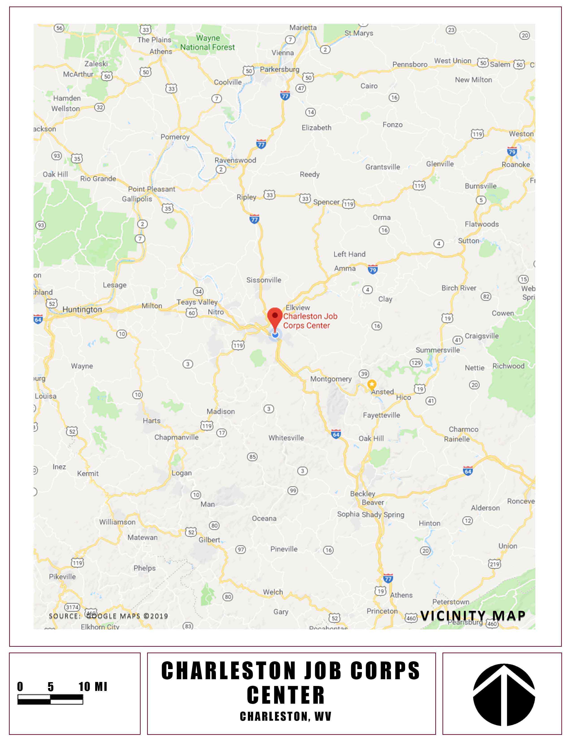

SITE PLAN

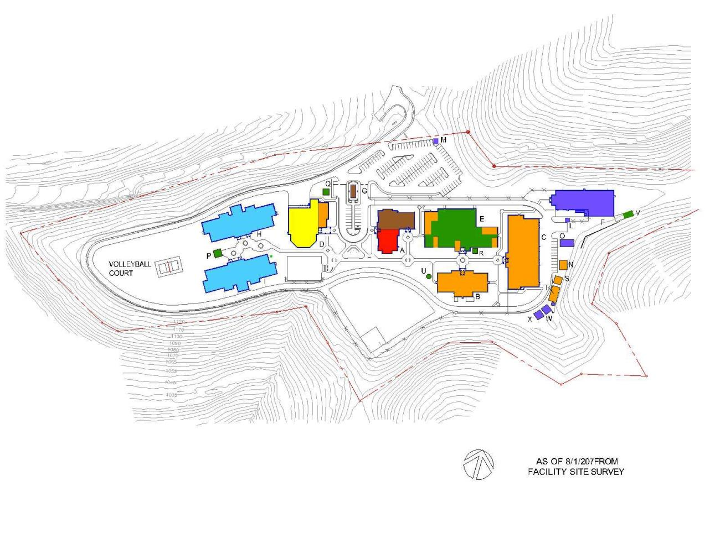

- SAMPLE SERVICE CONTRACT WEEKLY CERTIFIED PAYROLL FORM

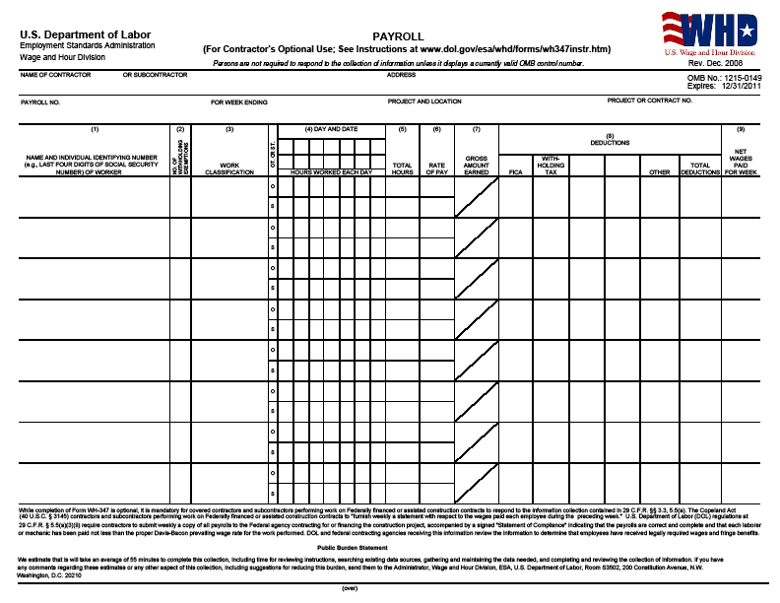

SAMPLE SERVICE CONTRACT WEEKLY CERTIFIED PAYROLL FORM, cont.

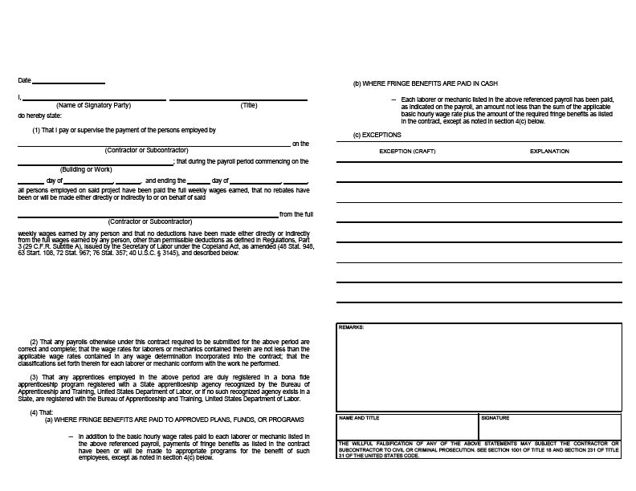

- Sample New Vendor Profile

New Vendor Registration Profile
Please complete this form, in its entirety
COMPANY INFORMATION:
Company Name:
Contact Name: |  |  |  |  |  |  |  |  |  |  |  |  |  |  |  |  | Title:
Address:
City: |  |  |  |  |  |  |  |  |  |  |  |  | State: |  |  |  |  |  |  |  | Zip Code:
Phone: |  |  |  |  |  |  |  |  |  | Other: ☐ Direct Dial ☐ Mobile
Fax Number: |  |  |  |  |  |  |  |  |  |  | Email:
Website: |  |  |  |  |  |  |  |  |  |  |  |  |  |  |  | Year Established:
EIN #: |  |  |  |  |  |  |  |  | DUNS #: |  |  |  |  |  |  |  |  | CAGE Code:
☐ Corporation ☐ LLC ☐ Partnership ☐ Sole Proprietorship ☐ Other: _________________________

REMIT PAYMENTS TO: (if different than above)
Address:
City: |  |  |  |  |  | State: |  |  | Zip Code:
Payment Terms: |  |  |  |  | Accounting POC:
Acct. POC Phone: |  |  |  |  | Acct. POC Email:

TYPE OF BUSINESS: (Check all that apply)
☐ Large (LG) ☐ Small (SB) ☐ Small Disadvantaged (SDB) ☐ HUBZone Small (HUB)
☐ Woman-Owned Small (WOSB) ☐ Veteran-Owned Small (VOSB)
☐ Service-Disabled Veteran-Owned Small (SDVOSB) ☐ Other: _______________________________
Description of Products or Services: (Include primary NAICS, if possible)

Under Section 16 of the Small Business Act and Title 13 of the Code of Federal Regulations, any person of concern that knowingly misrepresents the small business size status of a person or concern in connection with the federal government subcontracting opportunities is subject to penalties, including fines, imprisonment and debarment.

Signature |  | Title |  | Date

Return to:
Procurement Department, Charleston Job Corps

