Charleston Job Corps Center
1000 Curtis Price Way
Charleston, WV 25311

Needs to purchase the following:
Item | Quantity | Example
Height Adjustable Sneeze Guard 36”x48” | 20
Sneeze and Cough Protective Shield 32”x32” | 50 | 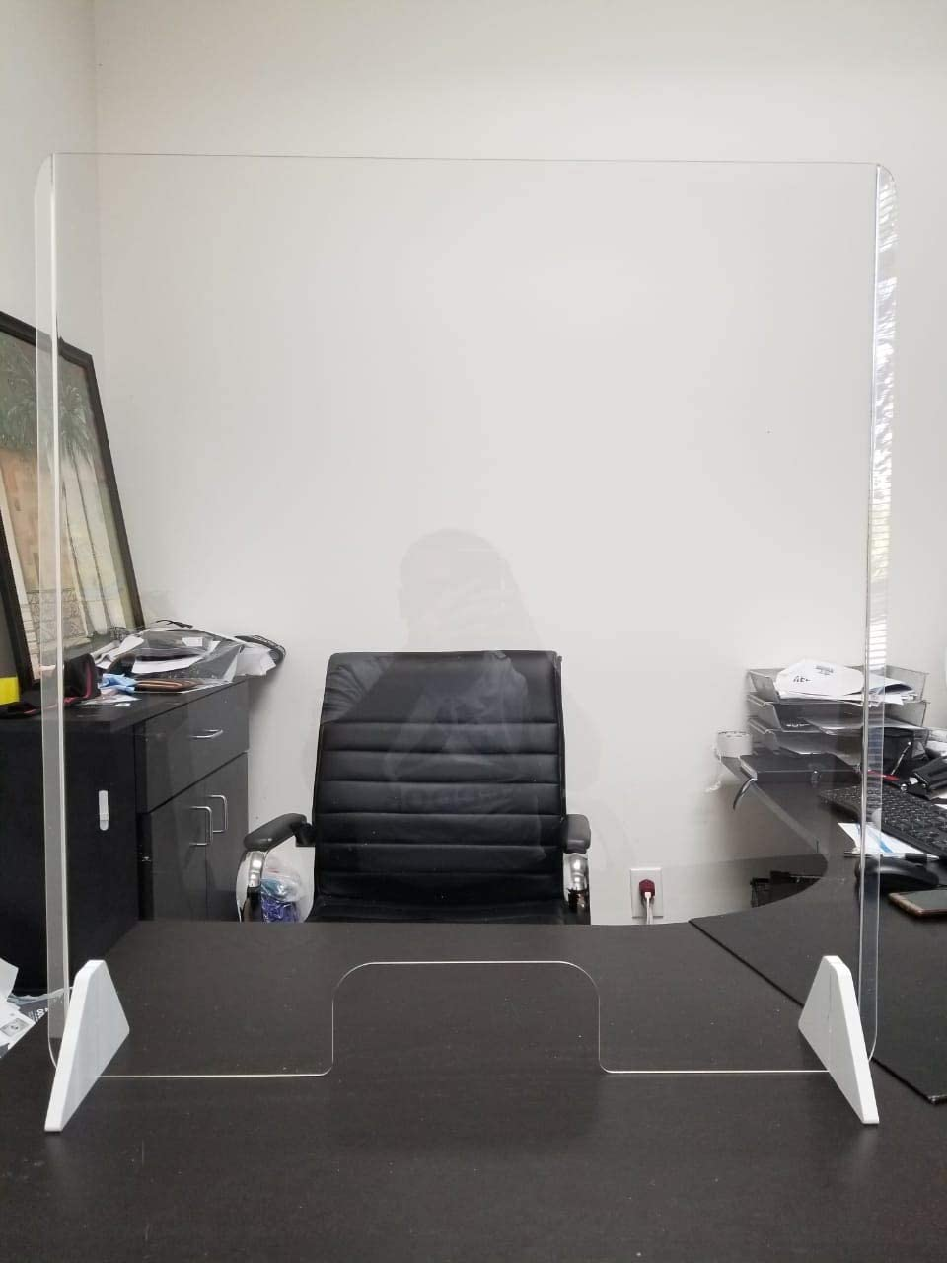
Free Floor Standing Sneeze Guard – Full Tarp with Roll Up | 10
Isolation Wall 6.5’ | 10
Clear Tarp Sneeze Guard – Full Tarp with EZ Extend Display 4’x8’ | 10
Protective Sneeze Guard 36”x30” Clear Acrylic Plexiglass Shield | 10 | 